**LEASE MANAGEMENT**

**College Name: NANDHA ARTS AND SCIENCE COLLEGE ERODE-52**

**College Code:** **bru4j**

**TEAM ID:**  **NM2025TMID22913**

**TEAM MEMBERS:**  **5**

**Team LeaderName:** VAIDHIGA A

**Email:** vaidhiga6374@gmail.com

**Team Member:** DHARANI R

**Email:** dharanirajadharani528@gmail.com

**Team Member:**  DEEPIKA M

**Email:** deepikadeepika03m@gmail.com

**Team Member:** KRISHNAN K

**Email:** Krishnanbscit@gmail.com

**Team Member:** SANTHIYA D

**Email:** 2326J1025@santhiya_dnandhaarts.org

# 1.INTRODUCTION

## 1.1 Project Overview

The Lease Management System is a Salesforce-based application designed to streamline the processes associated with leasing real estate properties. It handles tenant management, lease contracts, payments, and communication with automation features such as flows, approval processes, and email alerts.

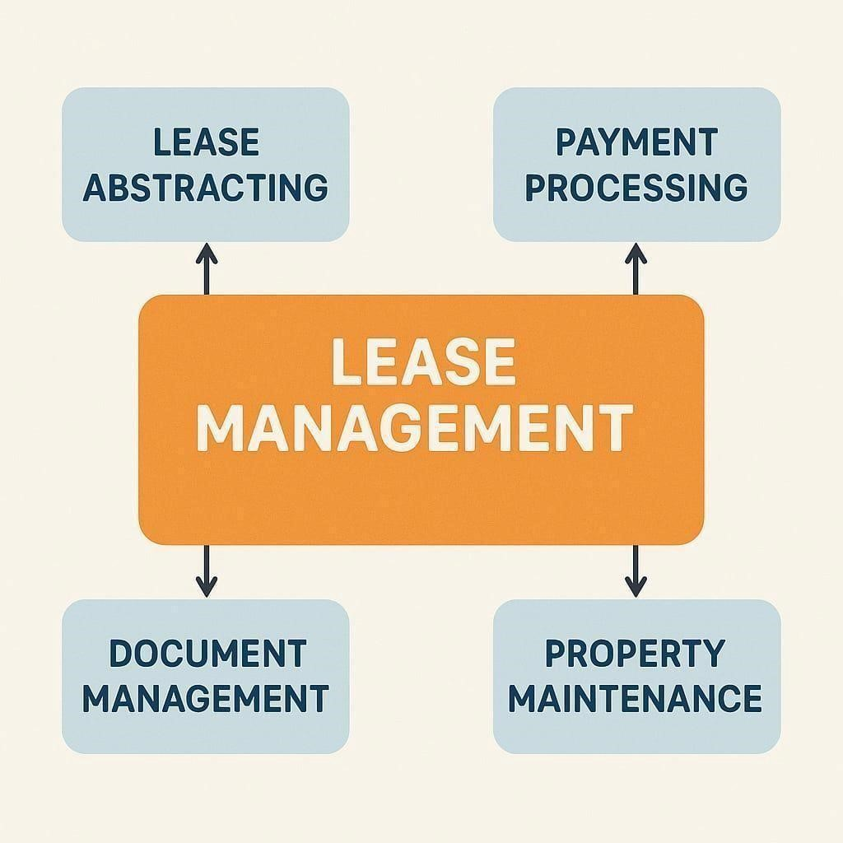

## 1.2 Purpose

The main objective of the project is to enable organizations to efficiently manage properties, tenants, and lease-related activities. It reduces manual intervention, improves accuracy, and ensures better compliance and communication.

# DEVELOPMENT PHASE

**Creating Developer Account:**

By using this URL[**- https://www.salesforce.com/form/developer-signup/?d=pb**](https://www.salesforce.com/form/developer-signup/?d=pb)

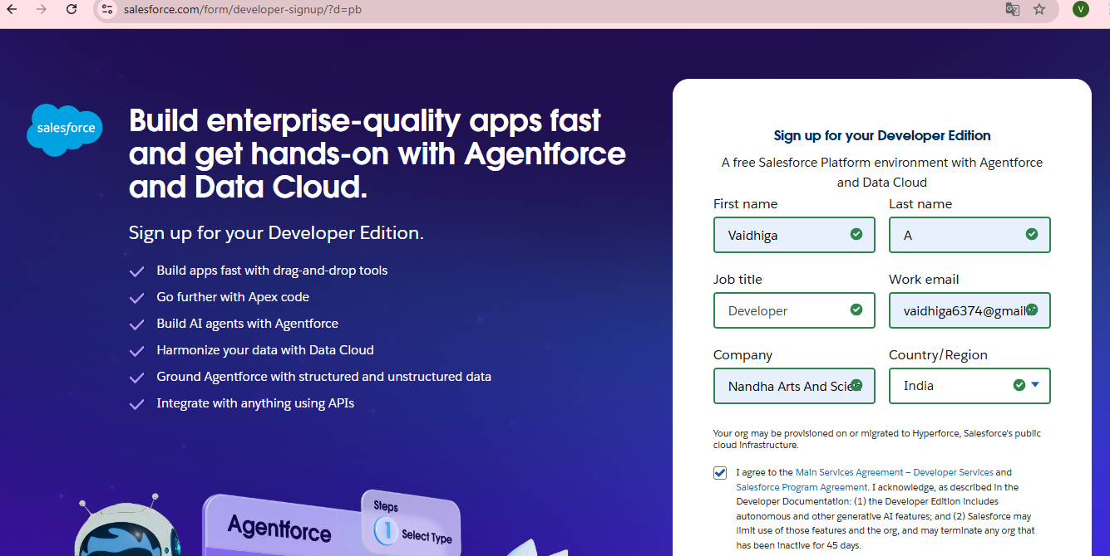

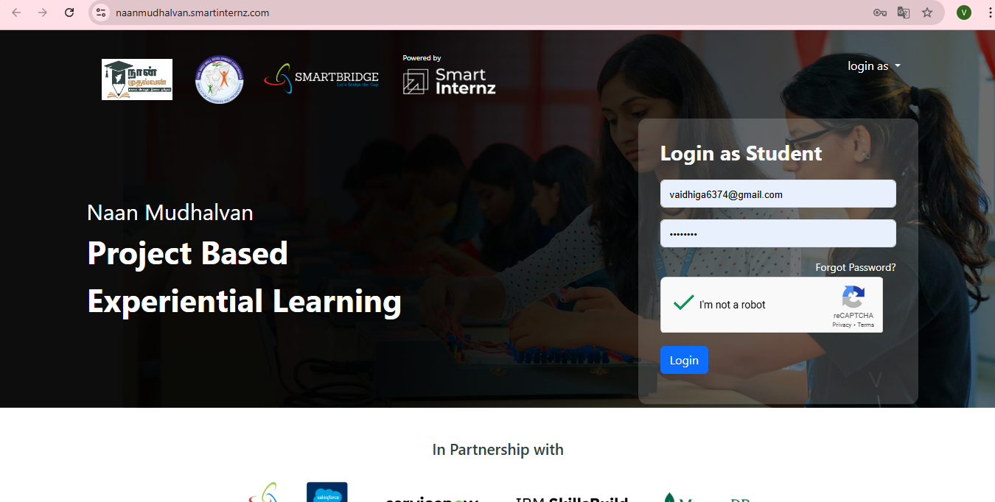

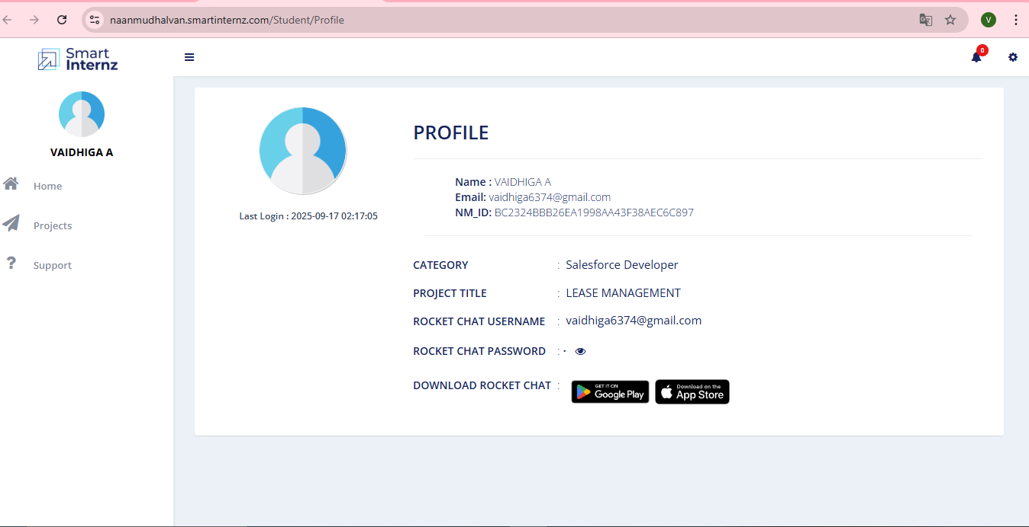

* Created objects: Property, Tenant, Lease, Payment

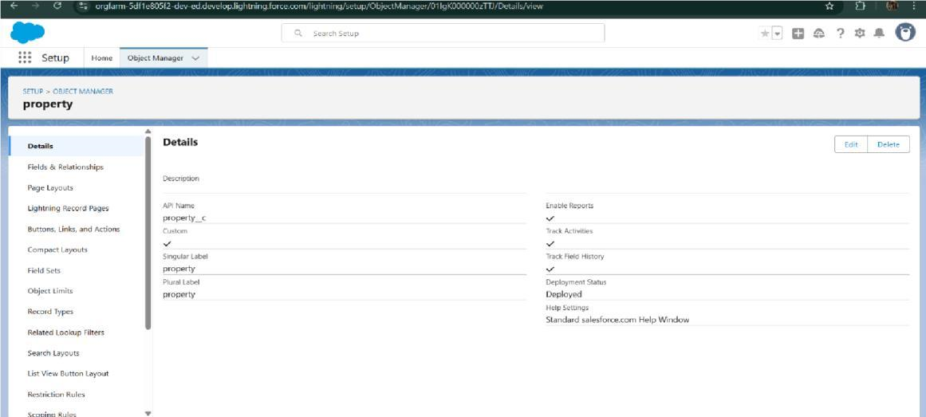

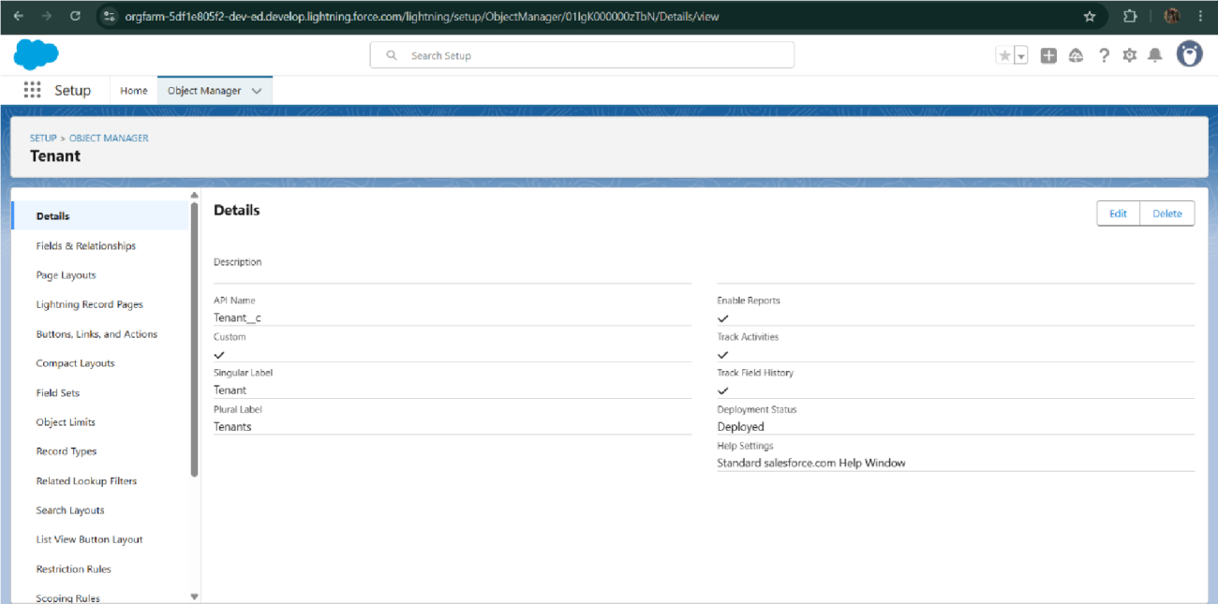

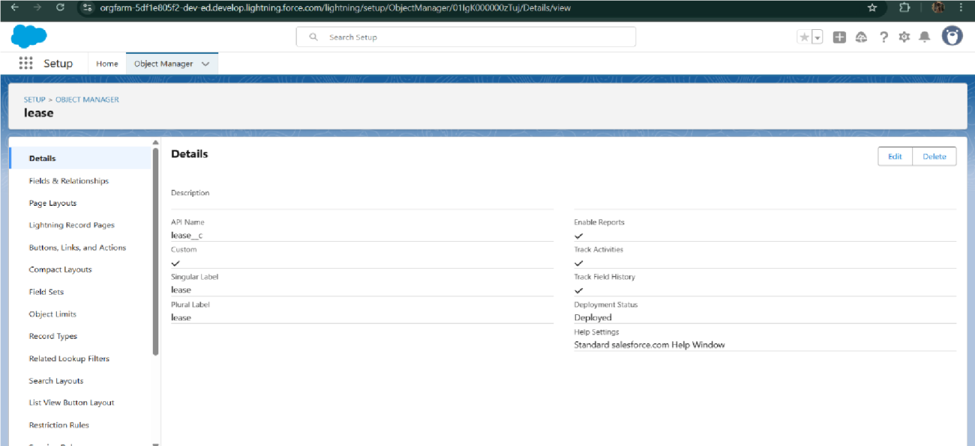

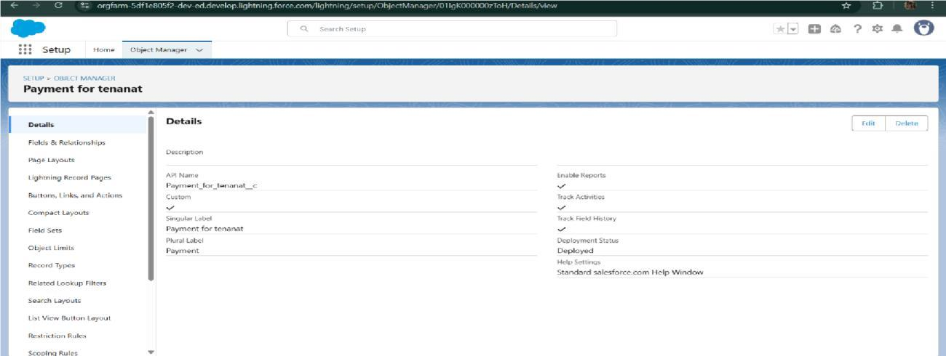

* Configured fields and relationships

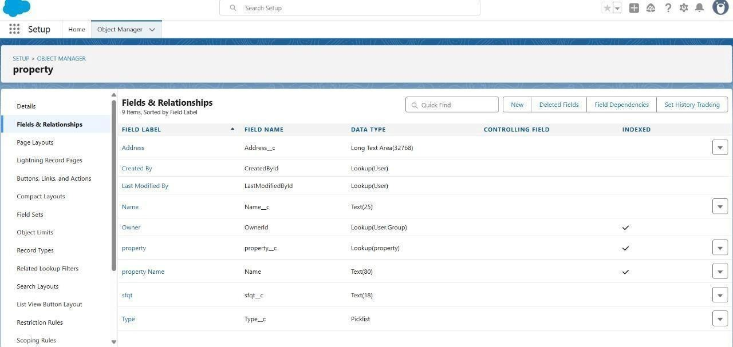

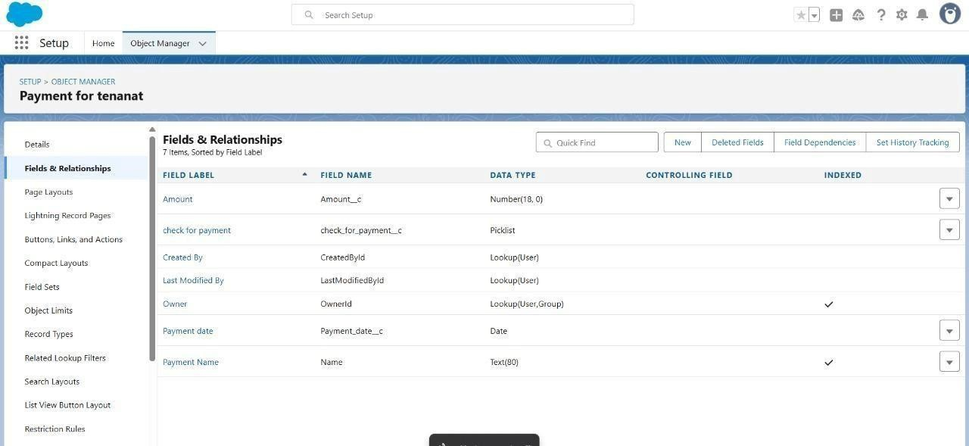

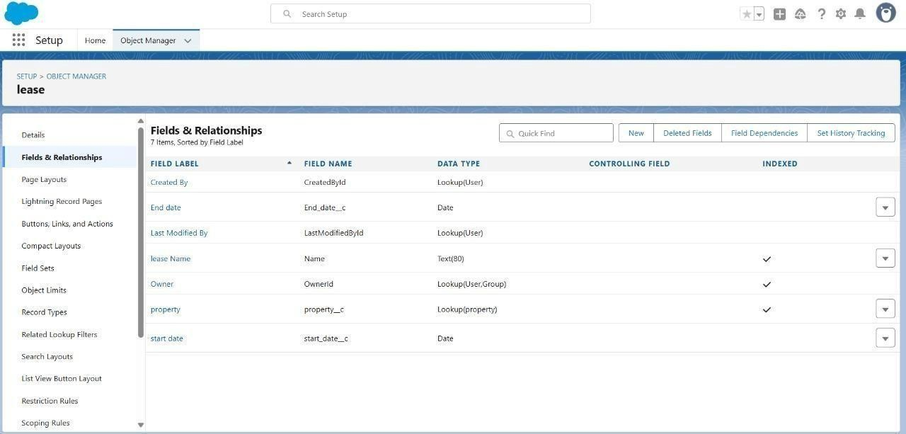

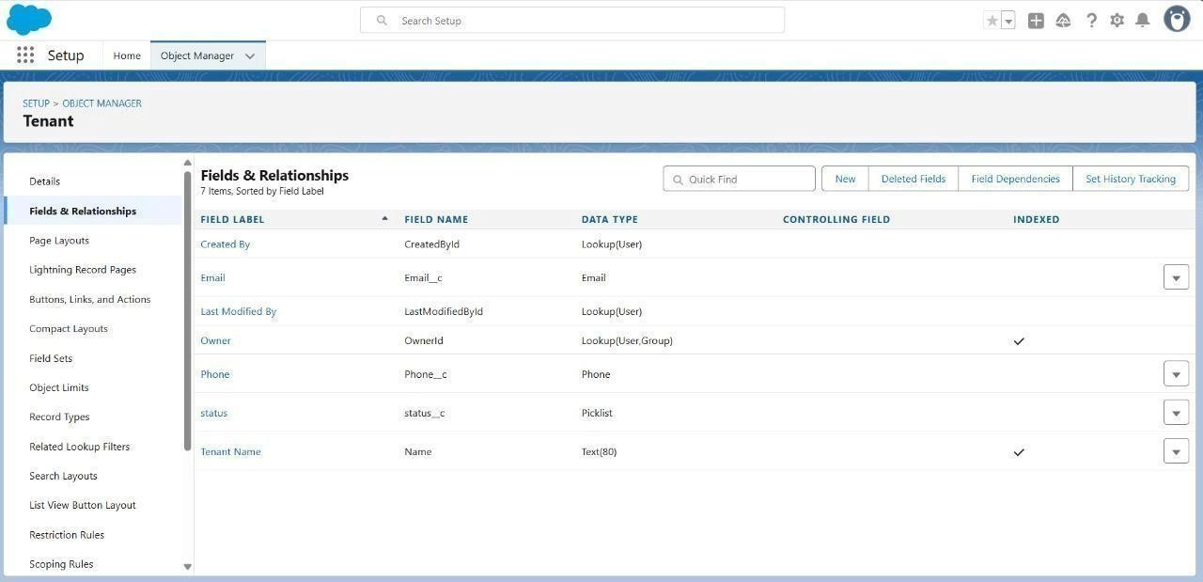

* Developed Lightning App with relevant tabs

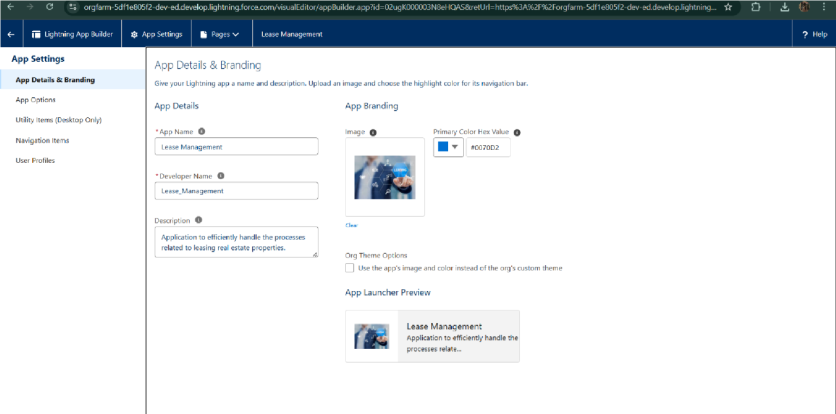

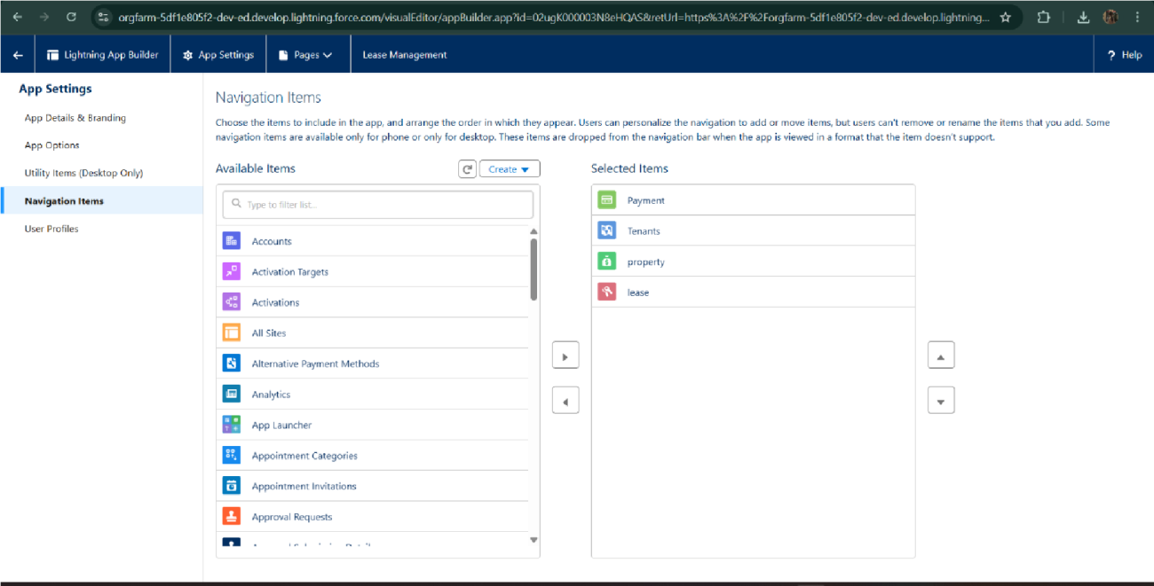

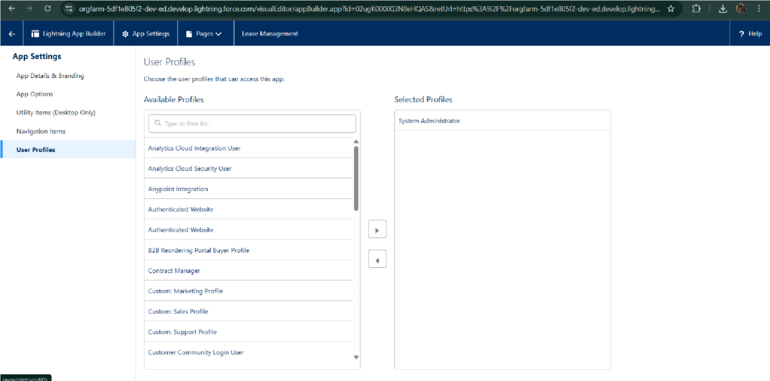

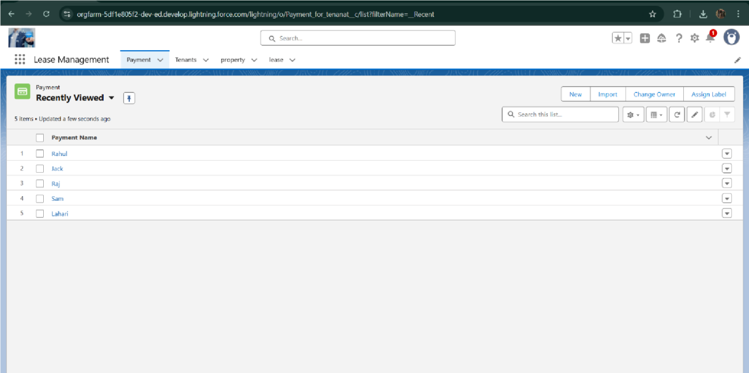

* Implemented Flows for monthly rent and payment success

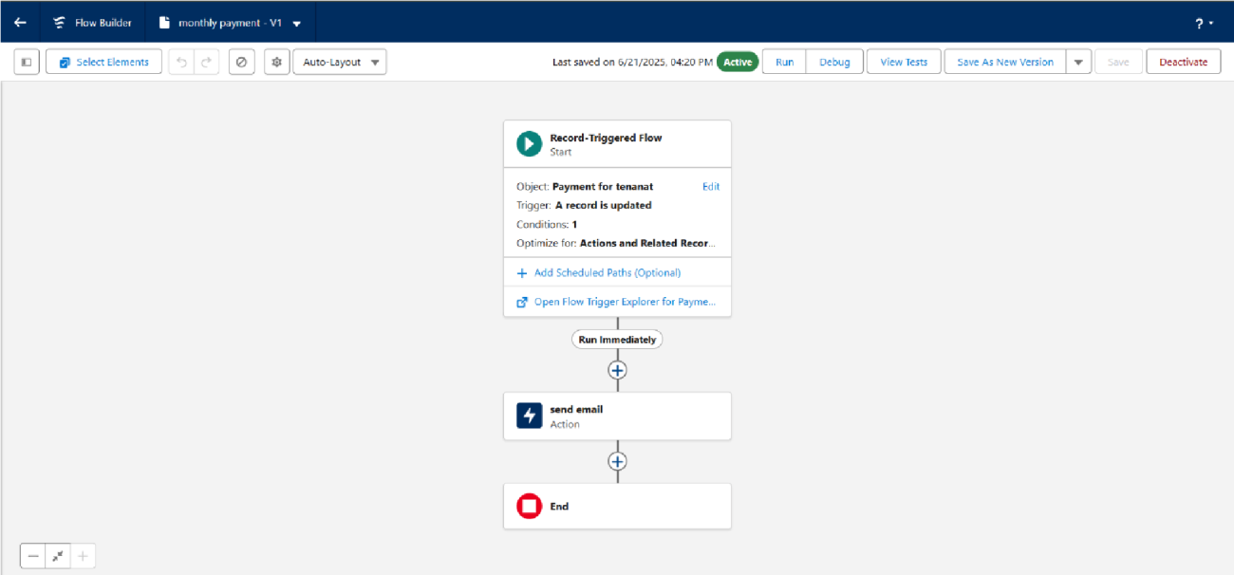

* To create a validation rule to a Lease Object

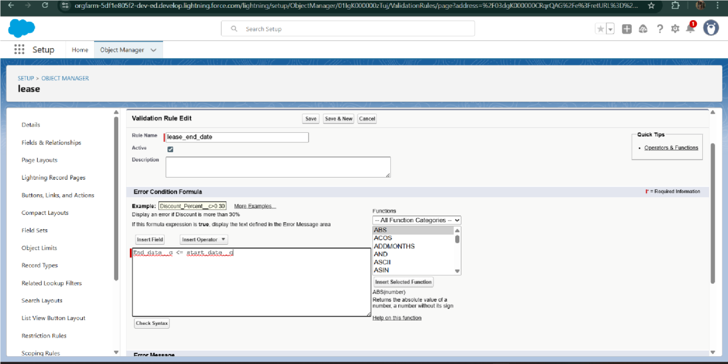

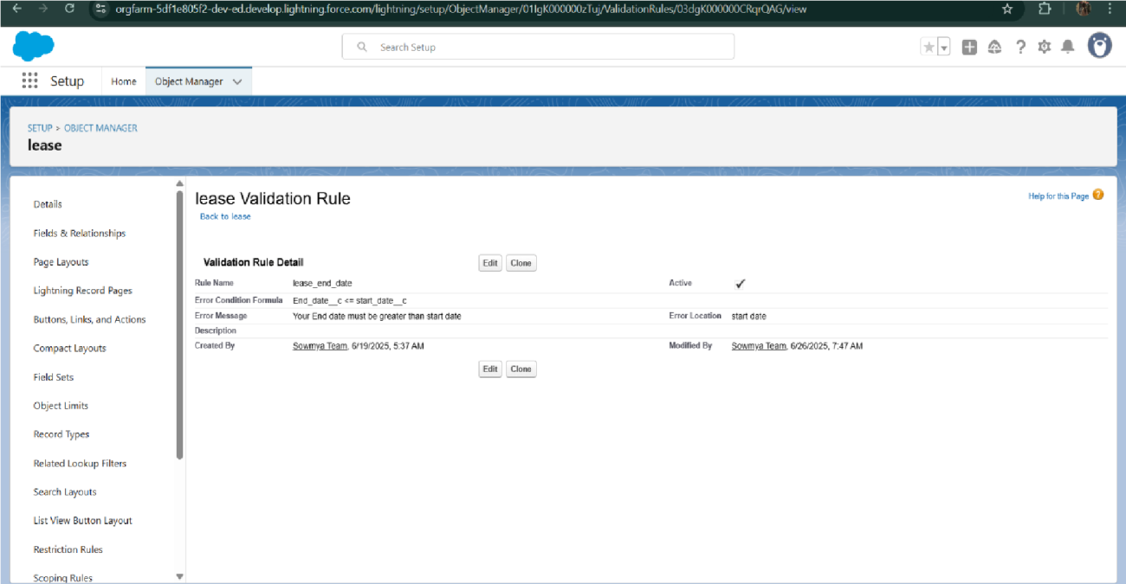

* Added Apex trigger to restrict multiple tenants per property

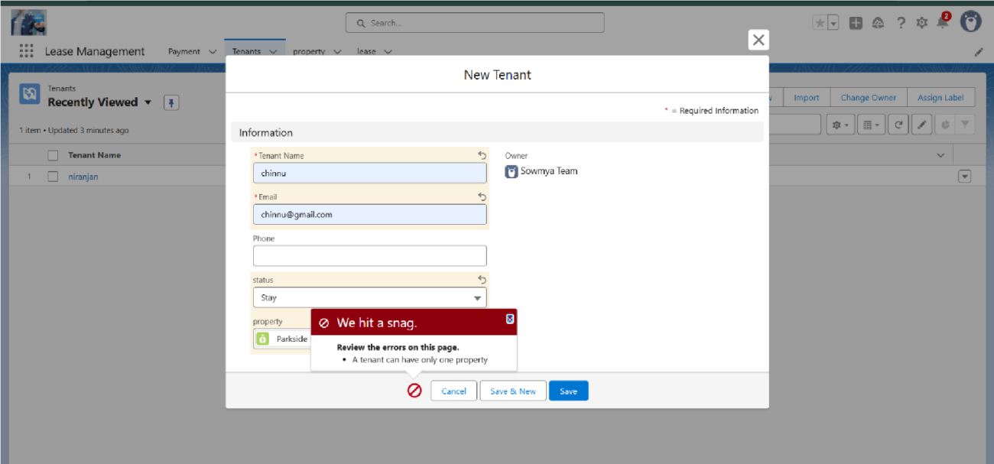

* Scheduled monthly reminder emails using Apex class

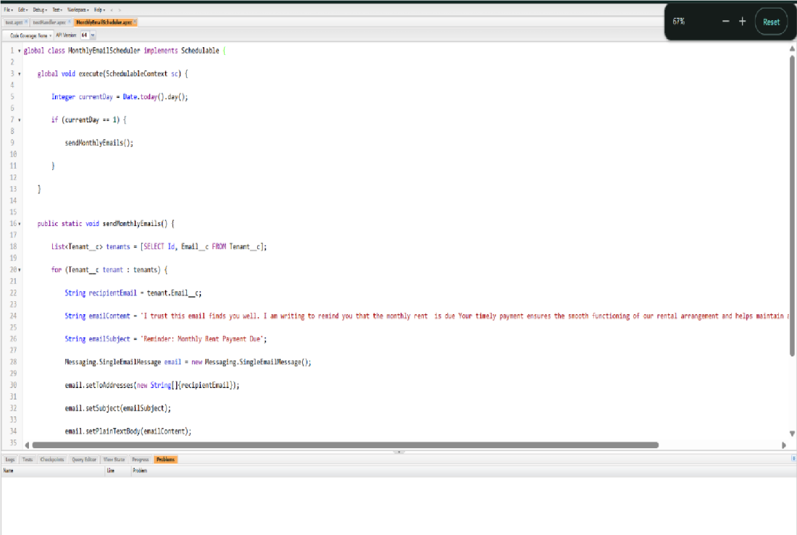

* Built and tested email templates for leave request, approval, rejection, payment, and reminders

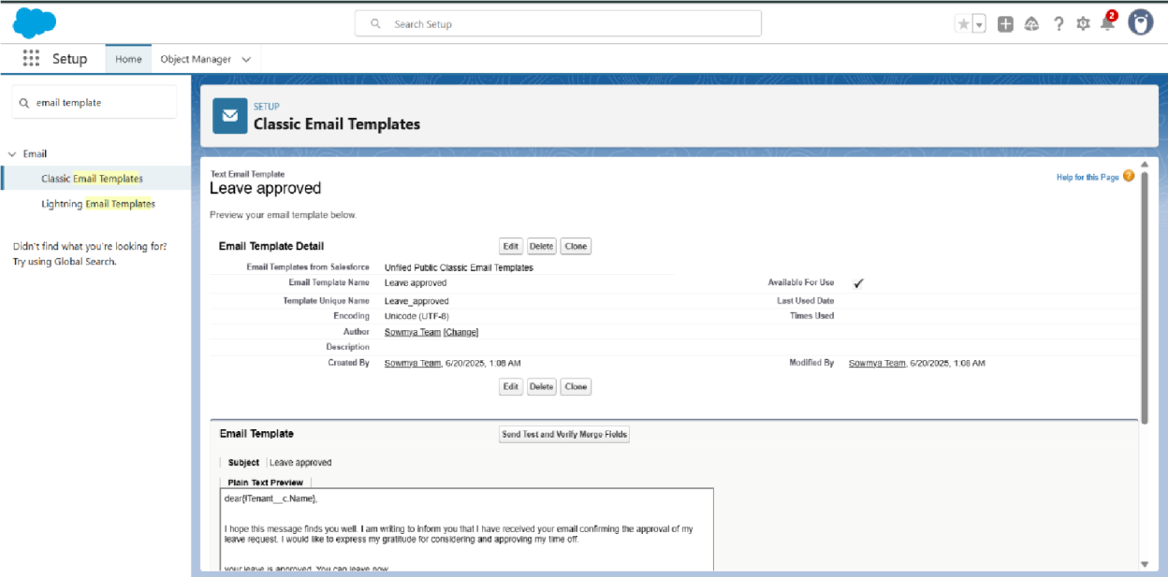

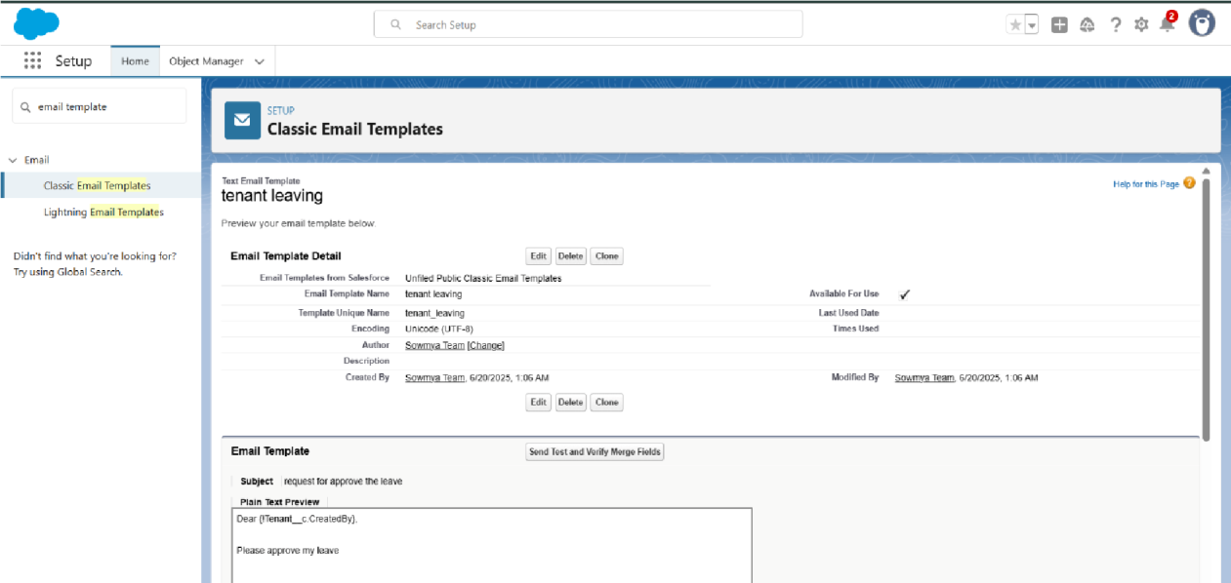

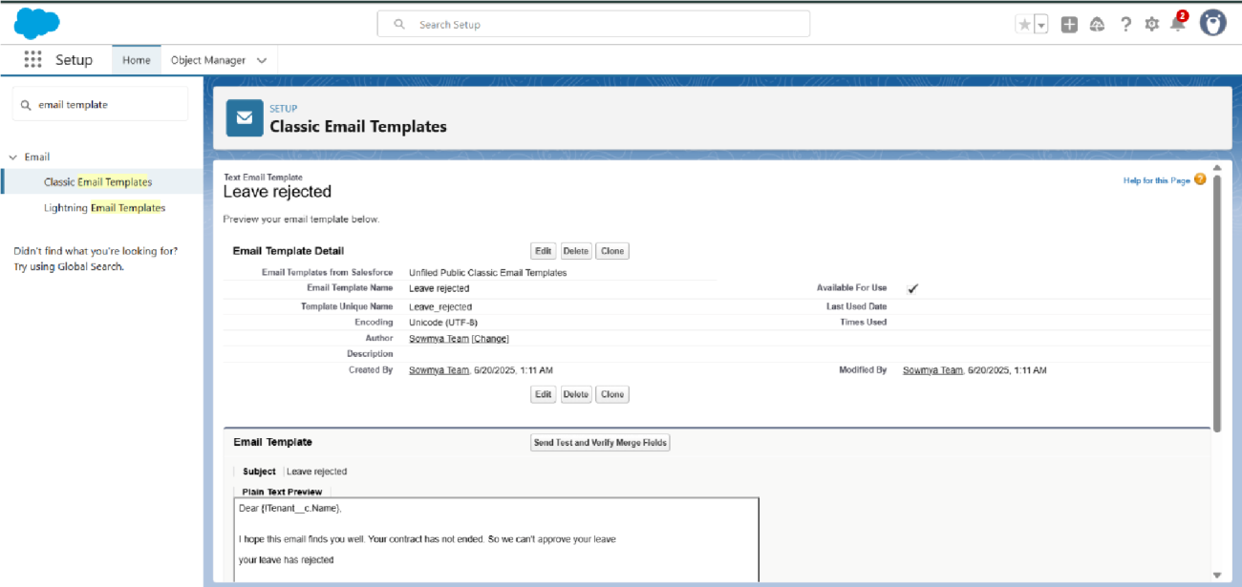

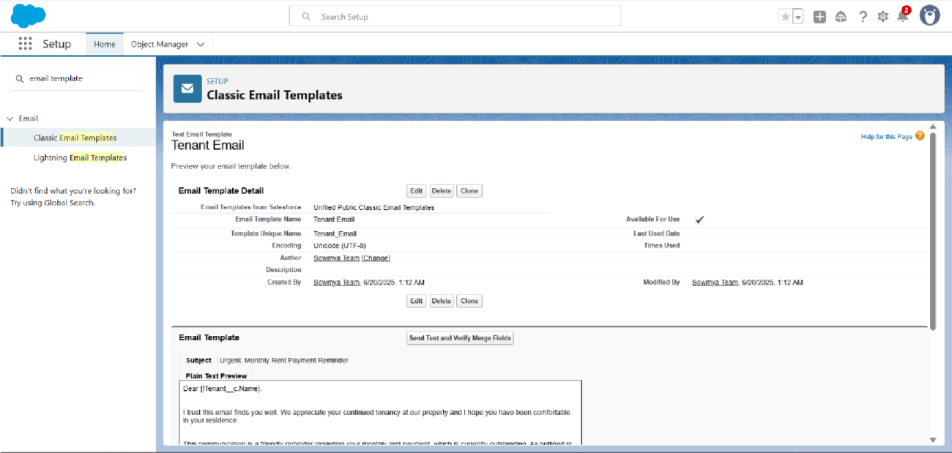

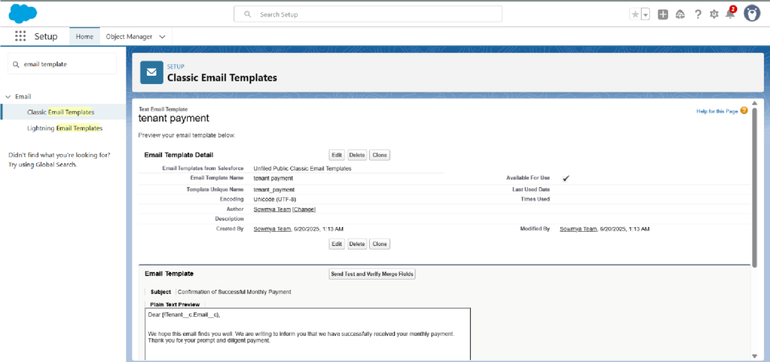

* Approval Process creation

For Tenant Leaving:

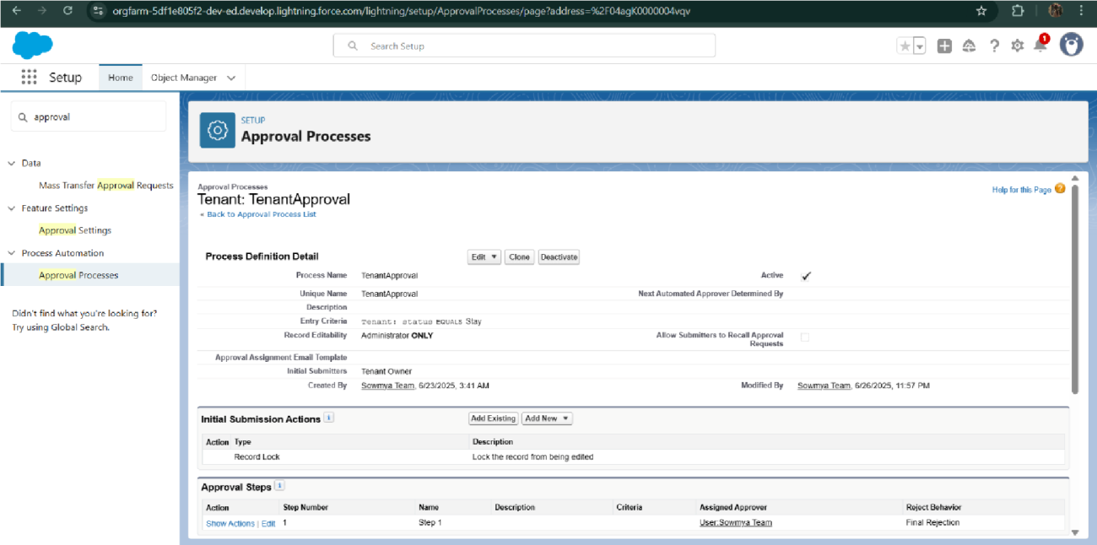

For Check for Vacant:

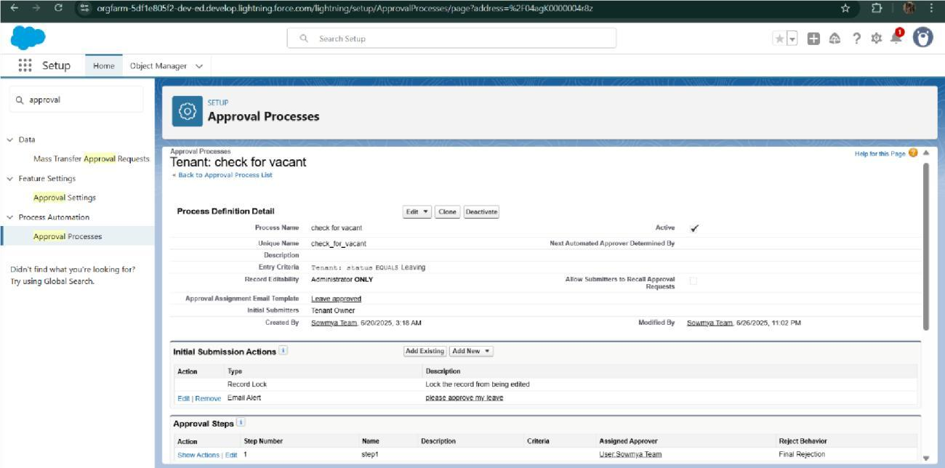

* Apex Trigger

Create an Apex Trigger

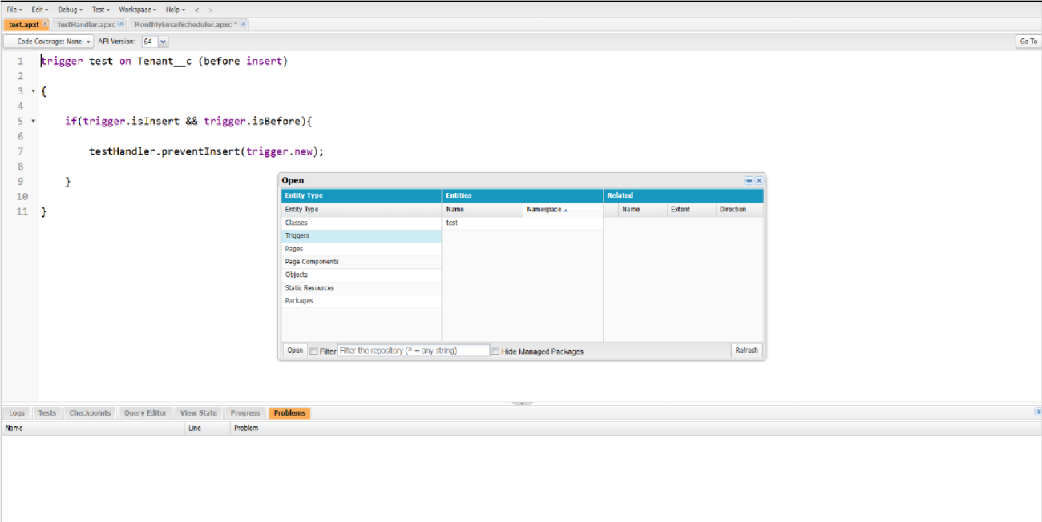

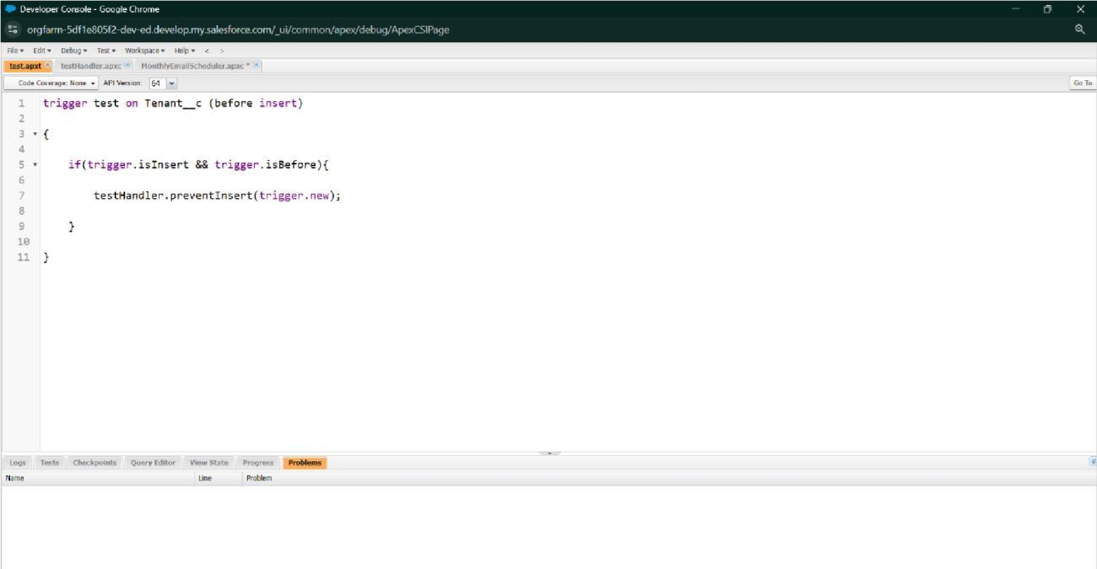

Create an Apex Handler class

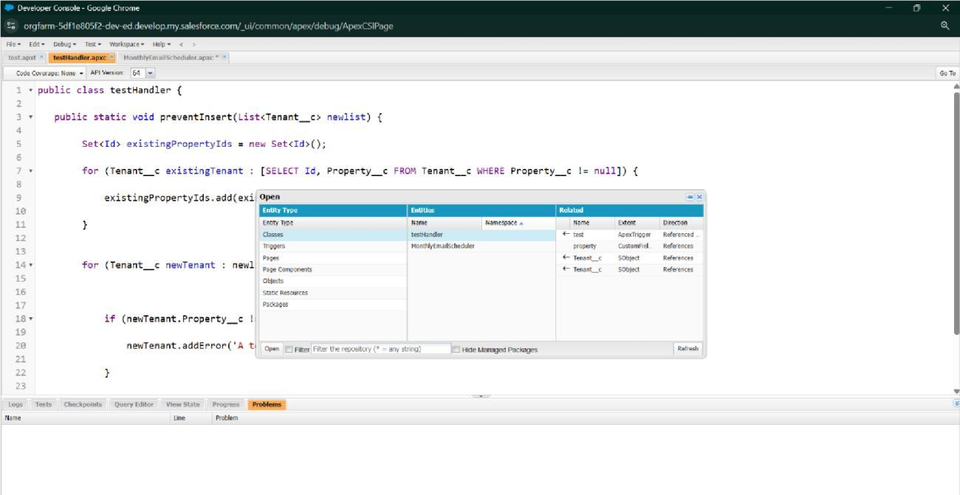

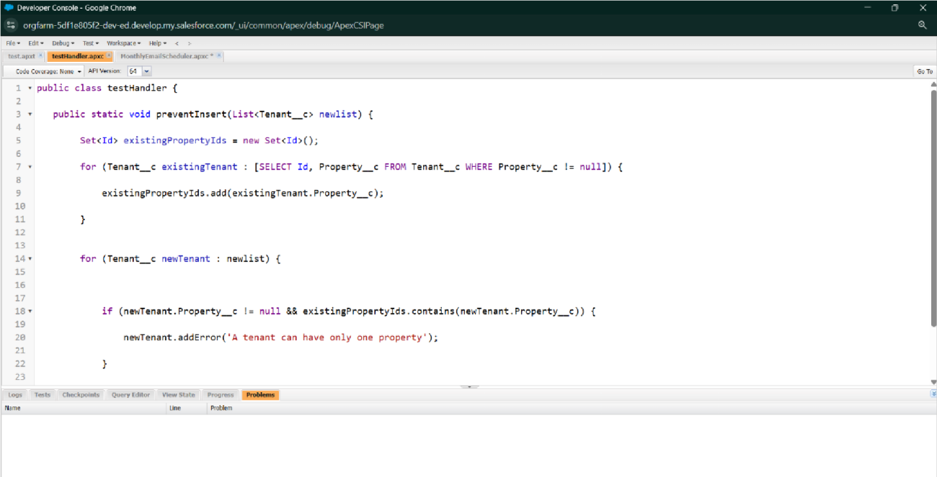

* FLOWS

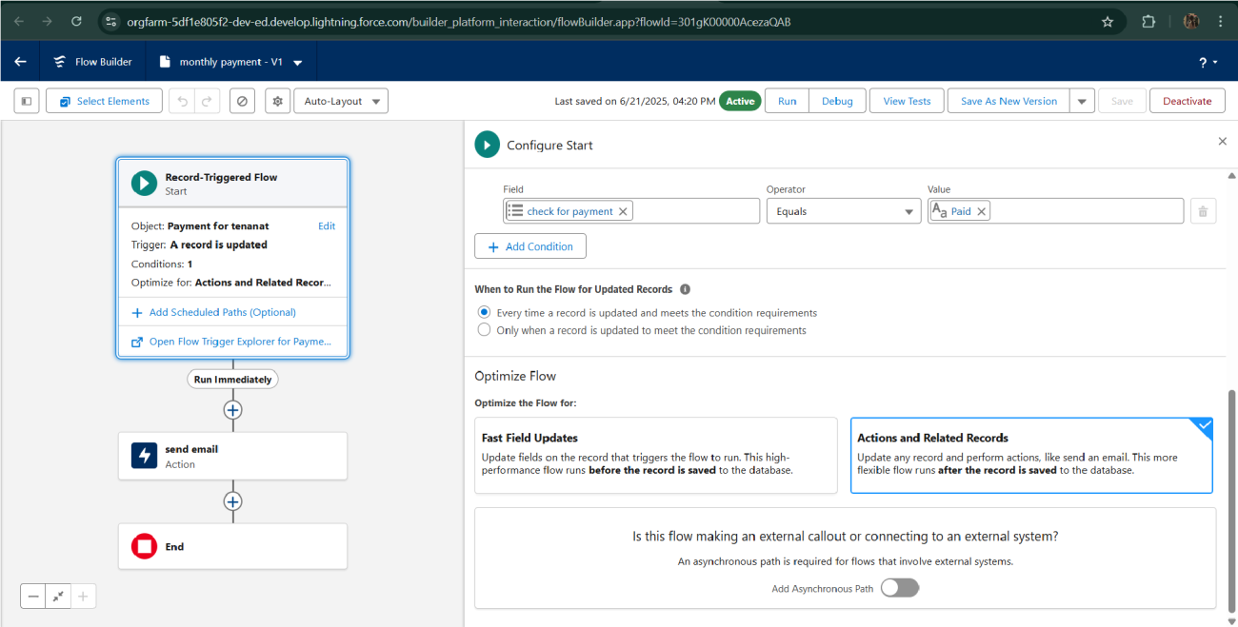

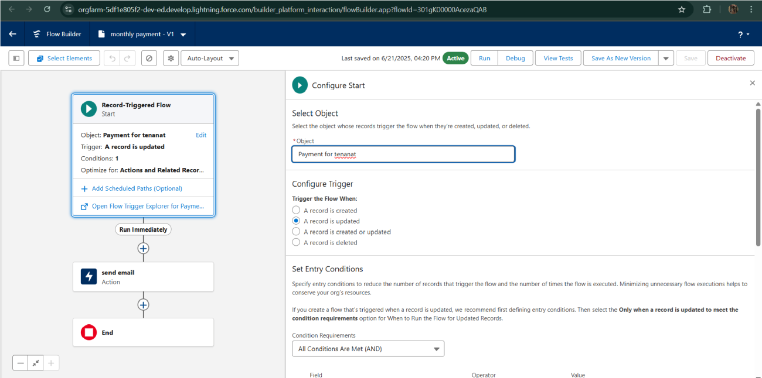

* Schedule class:

Create an Apex Class

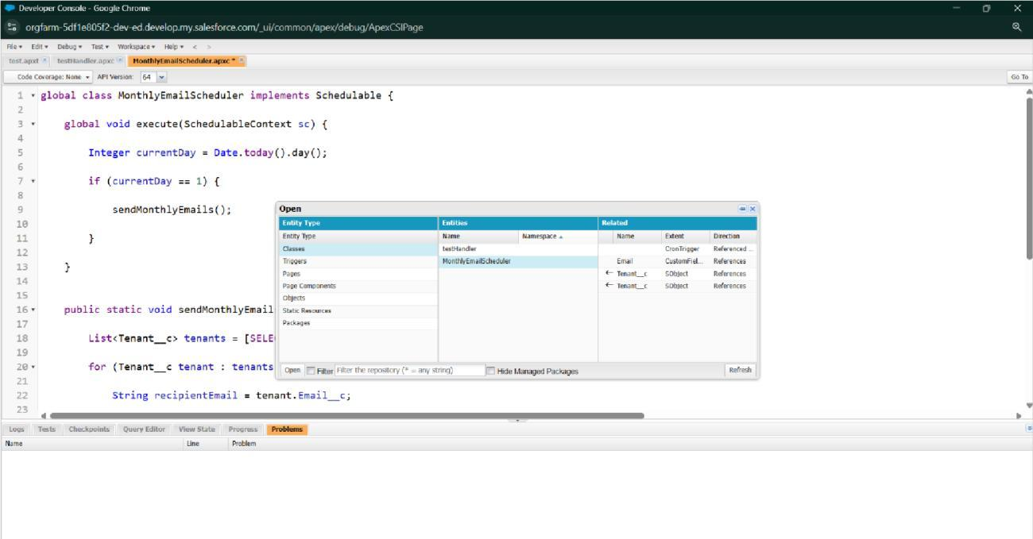

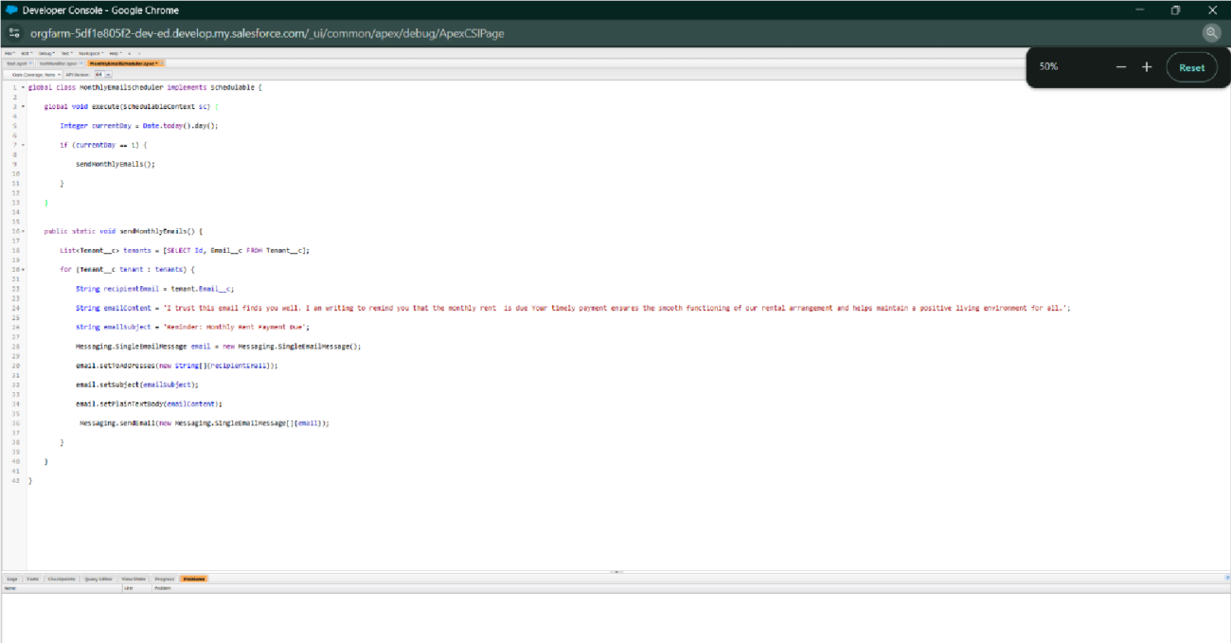

Schedule Apex class

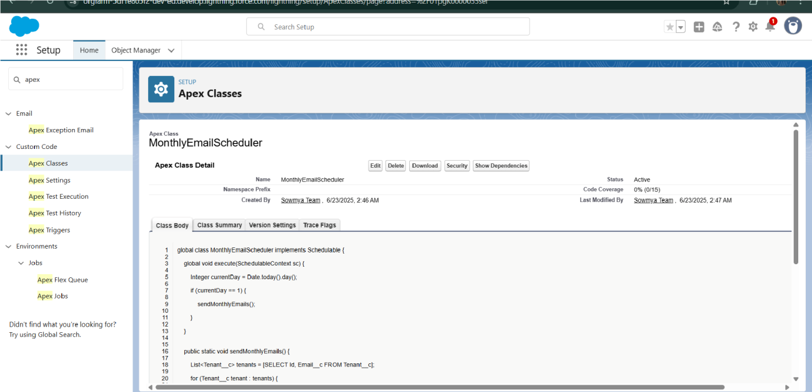

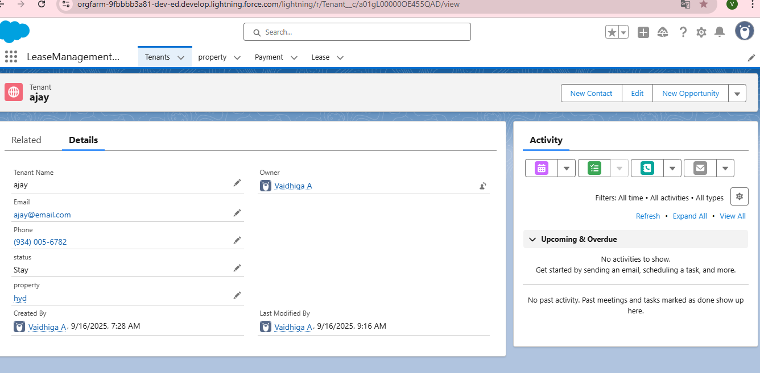

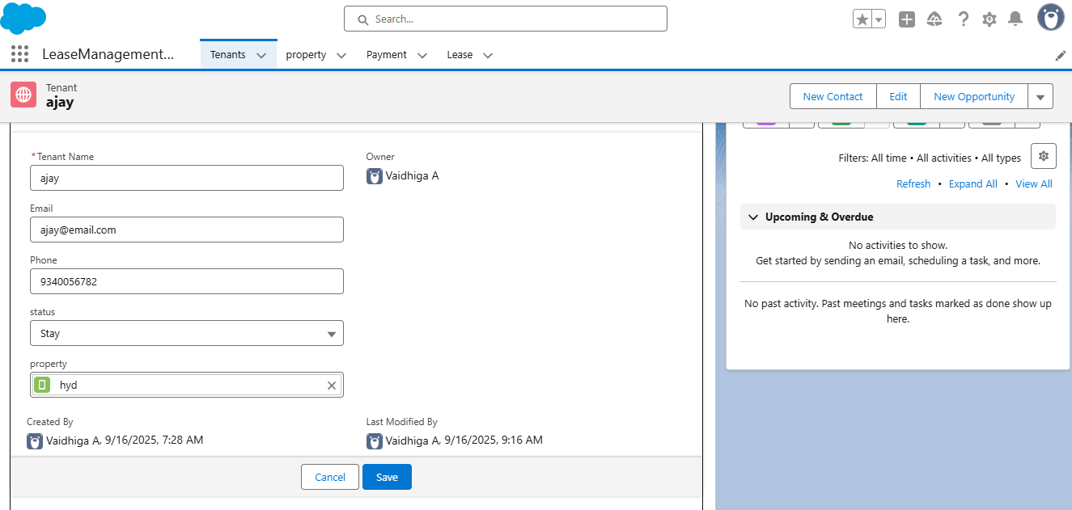

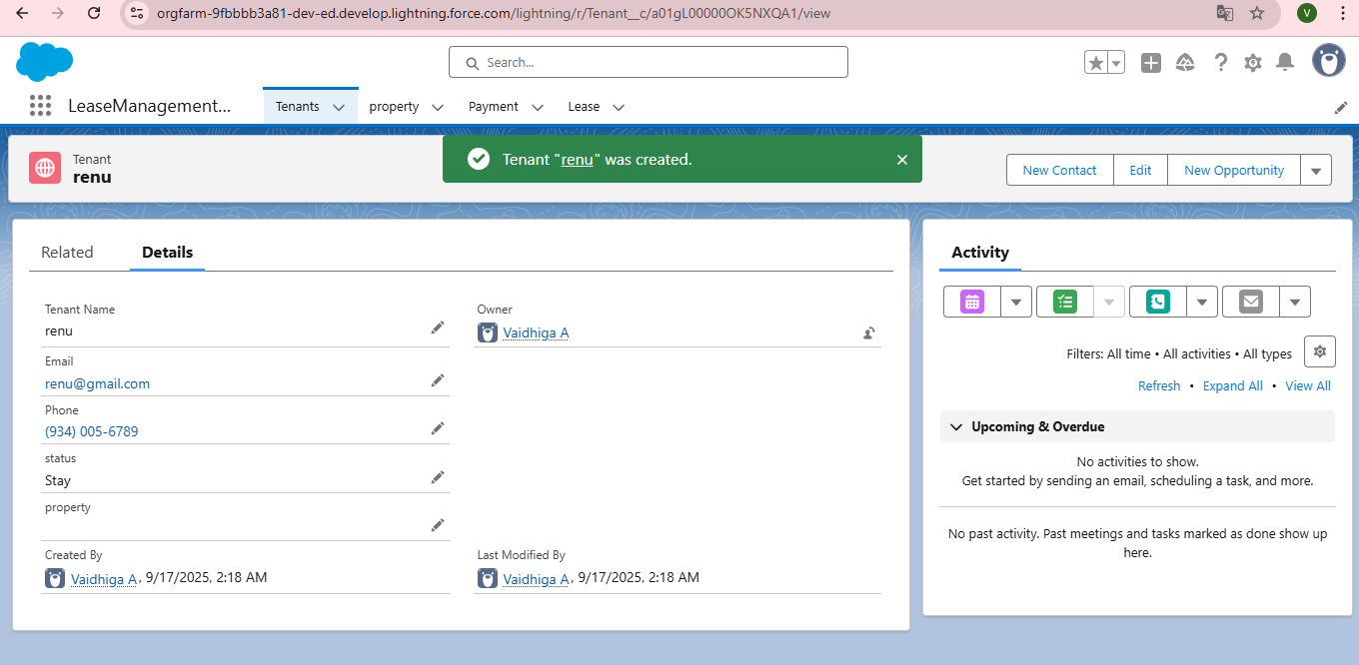

# FUNCTIONAL AND PERFORMANCE TESTING

## Performance Testing

* Trigger validation by entering duplicate tenant-property records

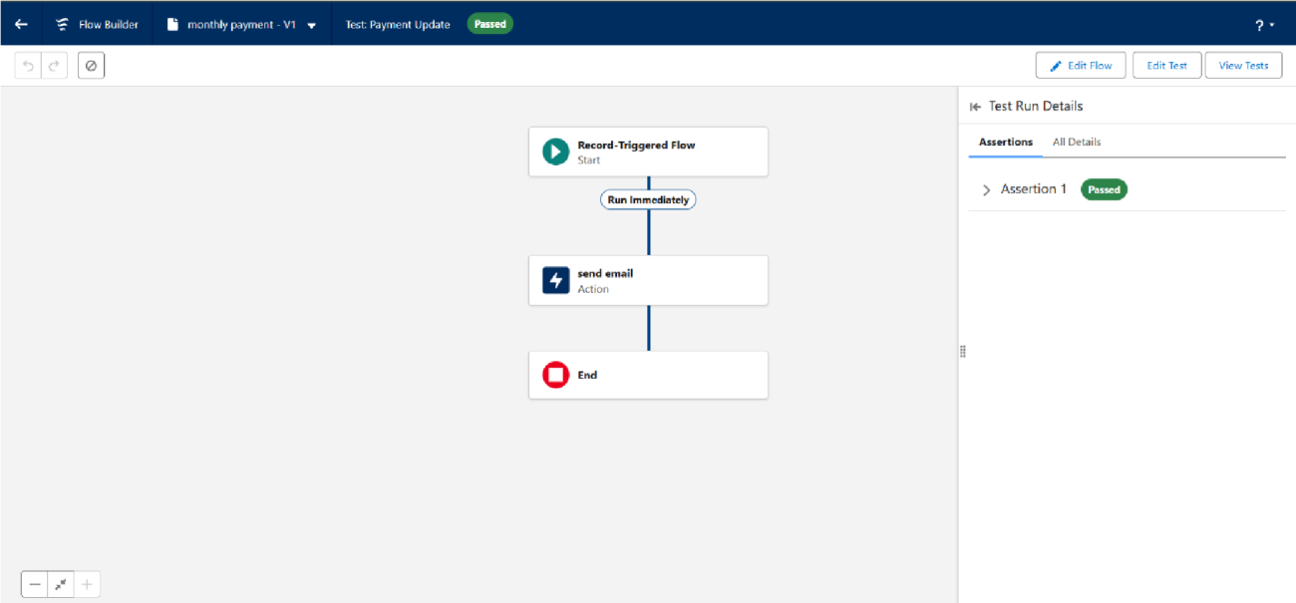

* Approval process validated through email alerts and status updates

# RESULTS

## Output Screenshots

* Tabs for Property, Tenant, Lease, Payment

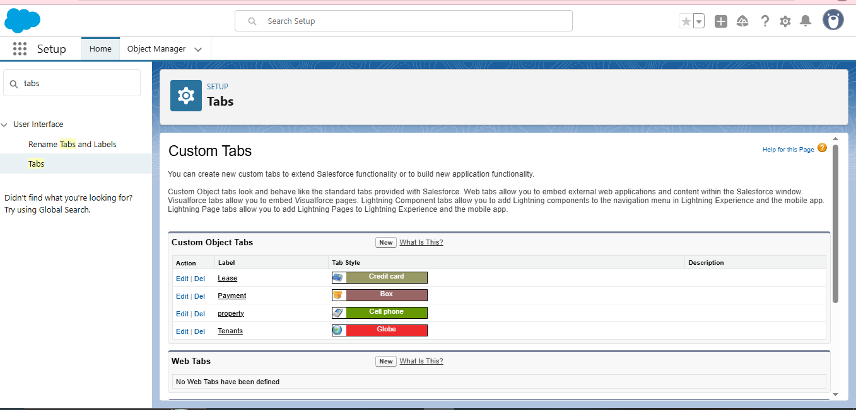

* Flow runs

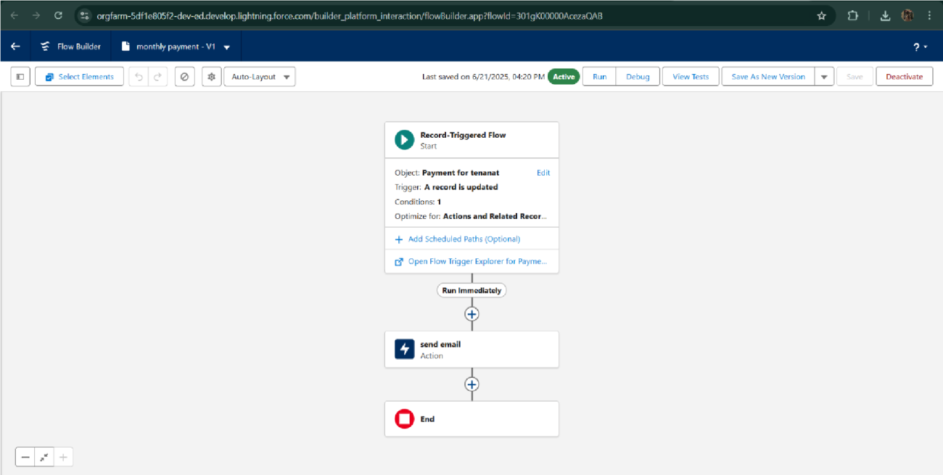

* Trigger error messages

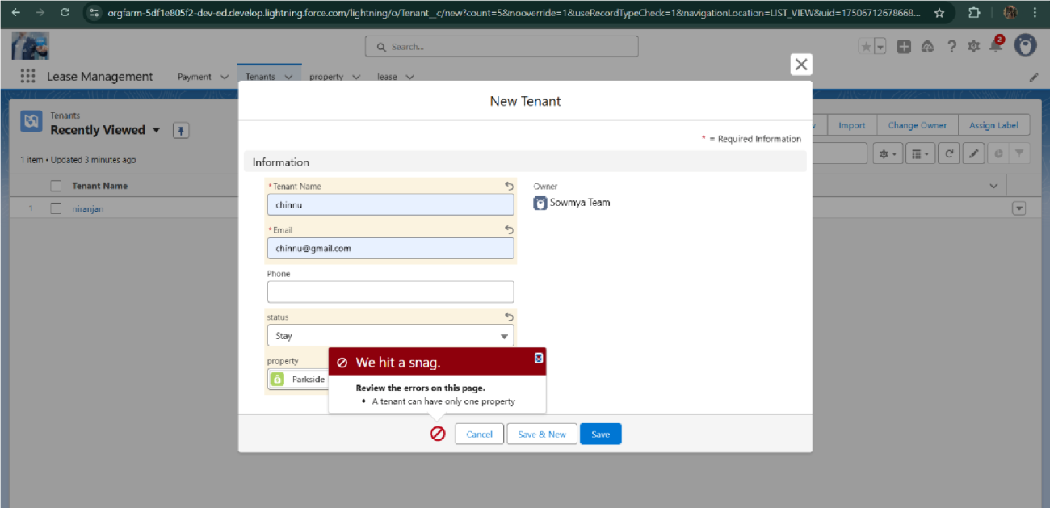

* Approval process notifications

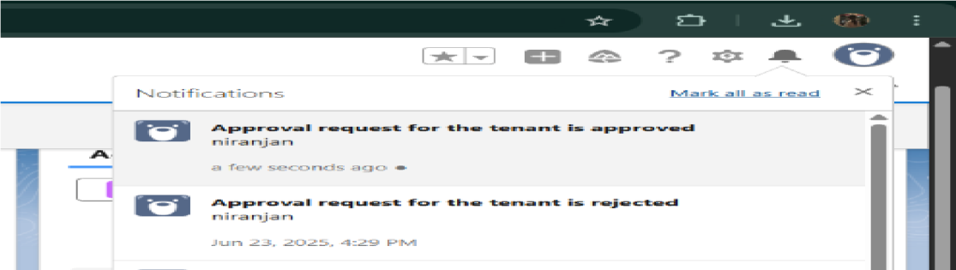

# CONCLUSION

The Lease Management System successfully streamlines the operations of leasing through a structured, automated Salesforce application. It improves efficiency, communication, and data accuracy for both admins and tenants.

## APPENDIX

● **Source Code:** Provided in Apex Classes and Triggers

**Test.apxt:**

trigger test on Tenant__c (before insert)

{ if (trigger.isInsert && trigger.isBefore)

{ testHandler.preventInsert(trigger.new);

}

}

**testHandler.apxc:**

public class testHandler { public static void preventInsert(List<

Tenant__c> newlist)

{ Set<Id>

existingPropertyIds

= new Set<Id>()

for (Tenant__c existingTenant : [SELECT Id, Property__c FROM Tenant__c

WHERE Property__c != null]) { existingPropertyIds.add(existingTenant.Property__c;

} for (Tenant__c newTenant :

newlist) {

if (newTenant.Property__c != null &&

existingPropertyIds.contains(newTenant.Property__c)) { newTenant.addError('A tenant can have only one property');

}

}

}

}

**MothlyEmailScheduler.apxc:**

global class MonthlyEmailScheduler implements Schedulable { global void execute(SchedulableContext sc) { Integer currentDay = Date.today().day(); if (currentDay == 1) { sendMonthlyEmails();

}

} public static void sendMonthlyEmails() { List<Tenant__c> tenants = [SELECT Id, Email__c FROM

Tenant__c]; for (Tenant__c tenant :

tenants) {

String recipientEmail = tenant.Email__c;

String emailContent = 'I trust this email finds you well. I am writing to remind you that the monthly rent is due Your timely payment ensures the smooth functioning of our rental arrangement and helps maintain a positive living environment for all.';

String emailSubject = 'Reminder: Monthly Rent Payment Due';

Messaging.SingleEmailMessage email = new

Messaging.SingleEmailMessage(); email.setToAddresses(new String[]{recipientEmail}); email.setSubject(emailSubject); email.setPlainTextBody(emailContent);

Messaging.sendEmail(new Messaging.SingleEmailMessage[]{email});

}

}

}